Task for today:

==============

1) Create a tomcat container on 8080 and deploy sample application in tomcat.  
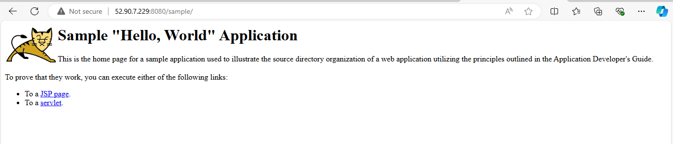

2) Create volume and deploy tomcat container on port 8081.  
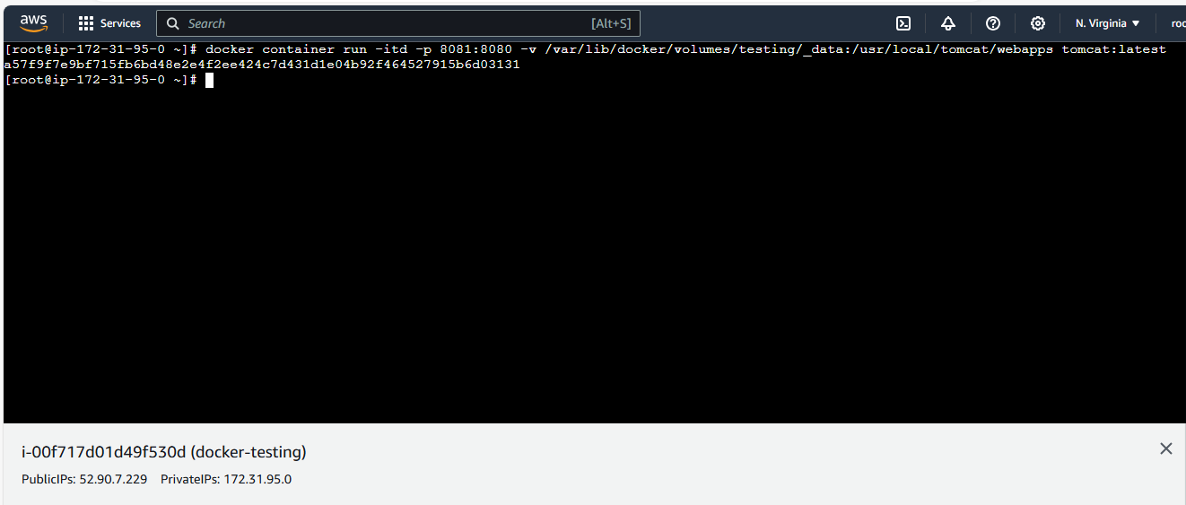  
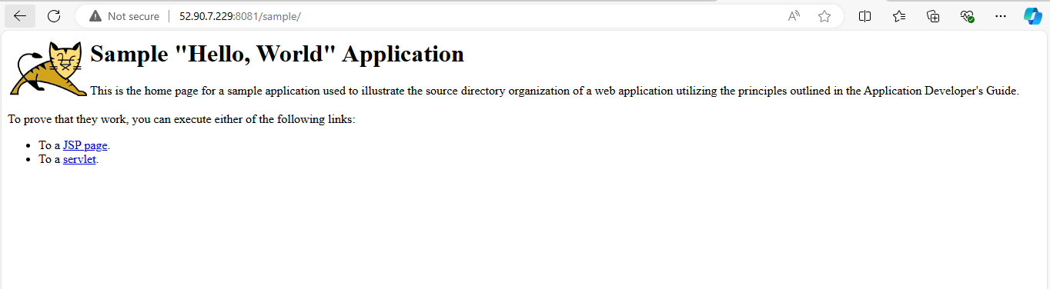

3) Limit the nginx container to 500 MB.  
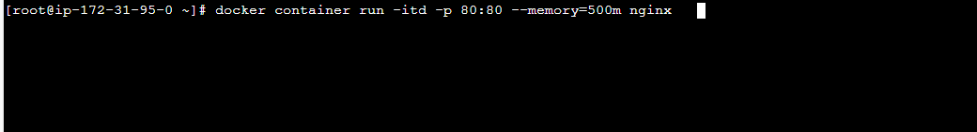  
  
checked the container: 🡪$ docker stats  


4) Create a sample docker file using below instructions.

1) Base module as amazonlinux:latest

2) Maintainer you name

3) Install nginx

4) COPY one index.html file to image  
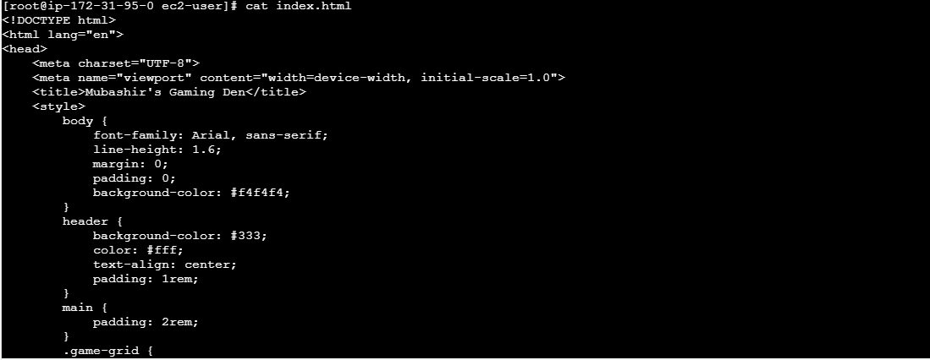

5) EXpose on port 80

6) Command to start the nginx container  
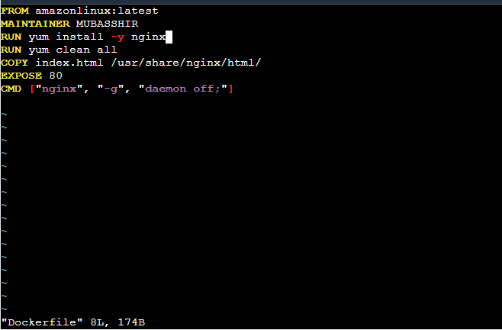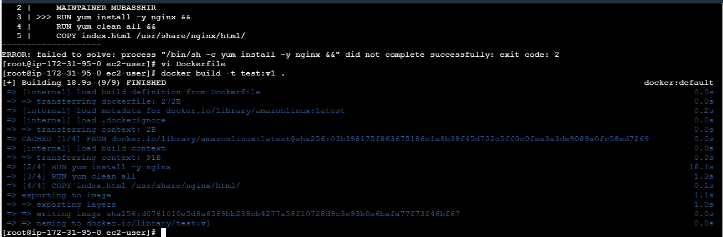

5) Push image to dockerhub  
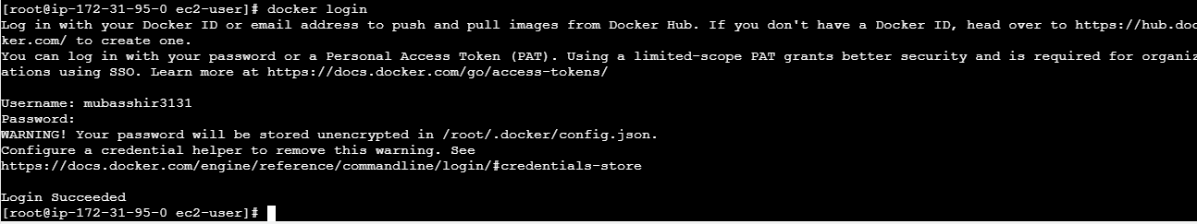  
now docker push:  
facing error as the image name should be same as repo name so I have changed the name of my image:  
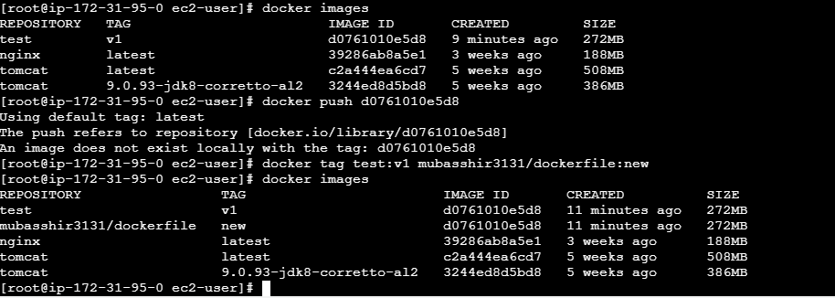  
Now I am pushing the image to the repo:  
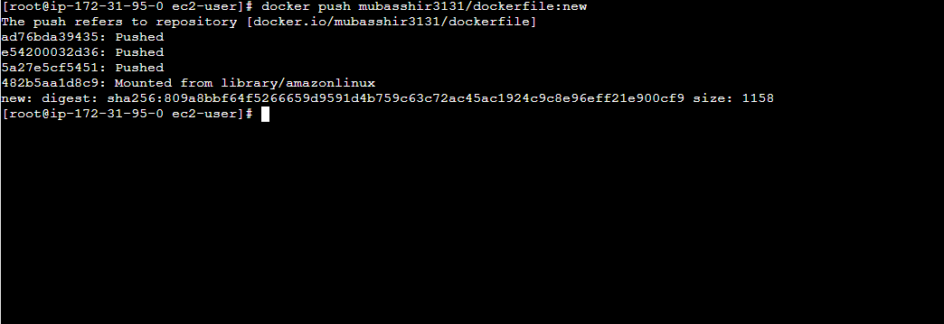   
checked in the docker hub:  
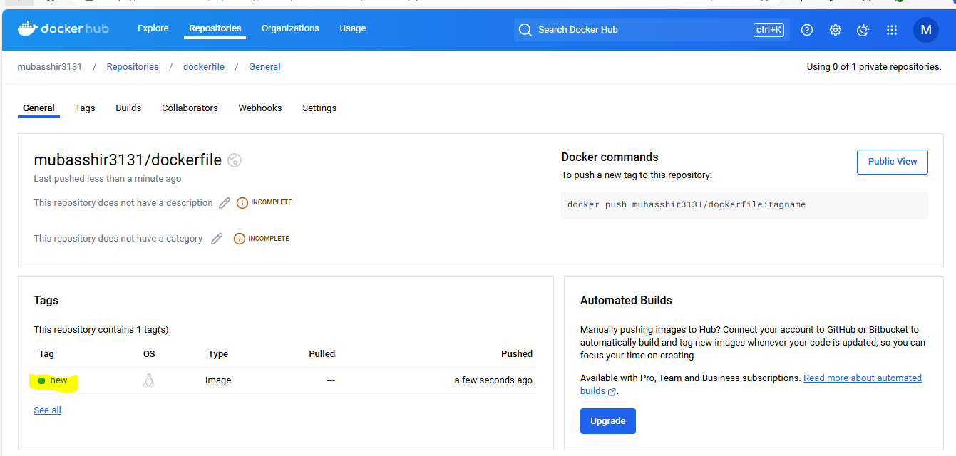

6) push image to aws ecr:  
Created an repo in ECR:  
  
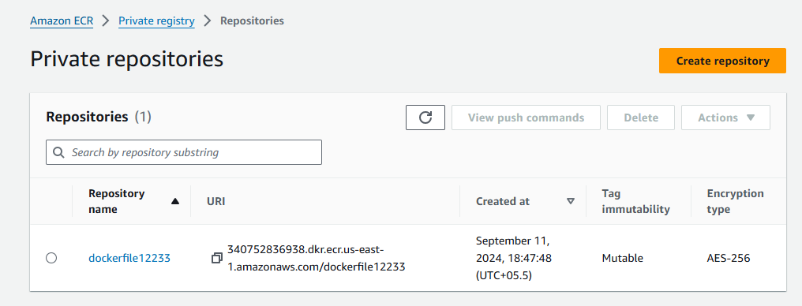  
  
then push the image in ECR:  
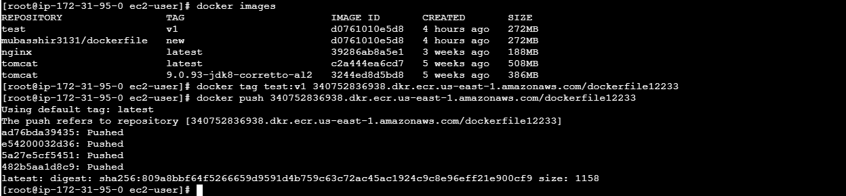  
cross verified in the aws console:  
